**Exercise: Asynchronous Programming**

Problems for exercises and homework for the ["JS Applications" course @ SoftUni](https://softuni.bg/courses/js-applications)   
Submit your solutions in the SoftUni Page - <https://softuni.bg/trainings/2347/js-apps-july-2019#lesson-11780>

1. **Forecaster**

Write a program that requests a weather report **from a** **server** and **displays** it to the user.

Use the skeleton from the provided resources.

When the user writes the name of a location and clicks “Get Weather”, make a GET request to the server at address https://judgetests.firebaseio.com/locations.json. The response will be an array of objects, with the following structure:

{

name: locationName,

code: locationCode

}

Find the object, corresponding to the name that the user submitted in the input field with ID "location" and use its **code** value to make **two more** GET **requests**:

* For current conditions, make a request to:

https://judgetests.firebaseio.com/forecast/today/{code}.json

The response from the server will be an object with the following structure:

**{**

**name: locationName,**

**forecast: { low: temp,**

**high: temp,**

**condition: condition }**

**}**

* For a 3-day forecast, make a request to:

https://judgetests.firebaseio.com/forecast/upcoming/{code}.json

The response from the server will be an object with the following structure:

**{**

**name: locationName,**

**forecast: [{ low: temp,**

**high: temp,**

**condition: condition }, … ]**

**}**

Use the information from these two objects to compose a forecast in HTML and insert it inside the page. Note that the <div> with ID "forecast" must be set to visible. See the examples for details.

If an **error** occurs (the server doesn’t respond or the location name cannot be found) or the data is not in the correct format, display "**Error**" in the **forecast section**.

Use the following codes for weather symbols:

* Sunny **&#x2600;** // ☀
* Partly sunny **&#x26C5;** // ⛅
* Overcast **&#x2601;** // ☁
* Rain **&#x2614;** // ☂
* Degrees **&#176;**  // °

**Examples**

When the app starts, the **forecast div** is **hidden**. When the user **enters a name** and **clicks** on the button **Get Weather**, the requests being.

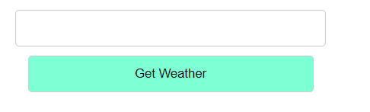

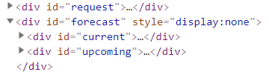

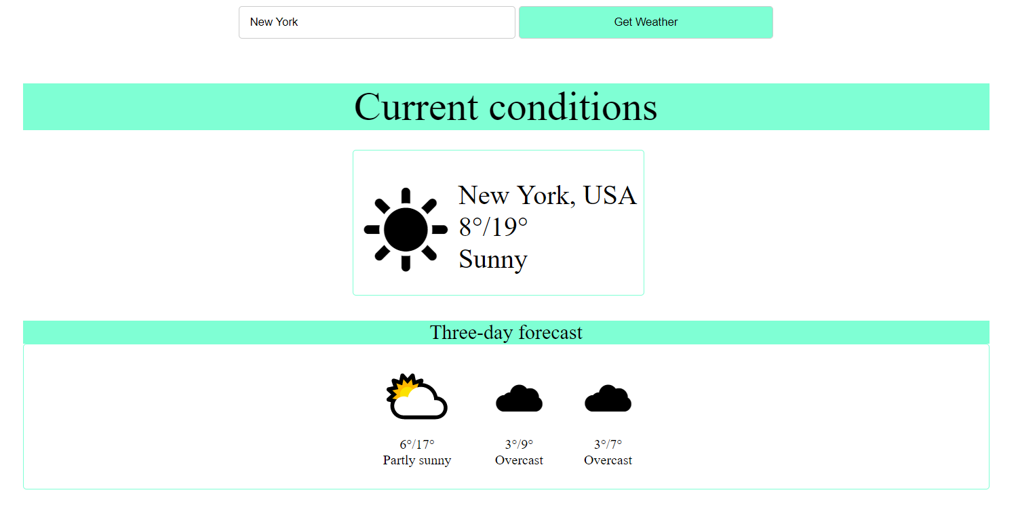

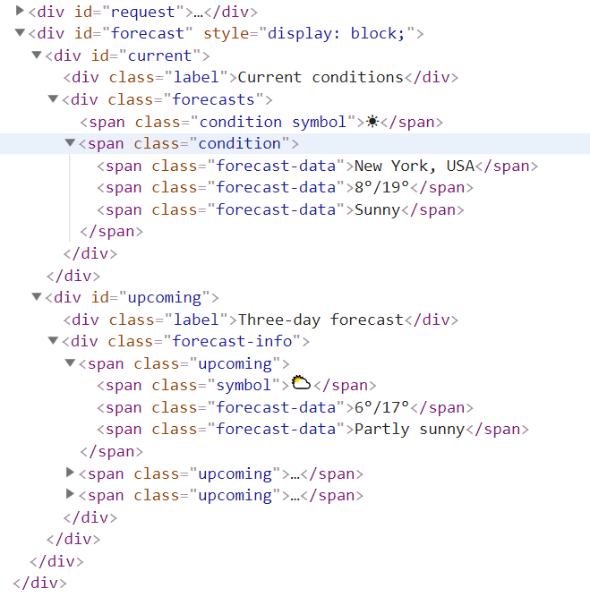

**Hints**

The server at the address listed above will respond with valid data for location names "**London**", "**New York**" and "**Barcelona**".

1. **Fisher Game**  
   Each catch should have:

* angler - string representing the name of the person who caught the fish
* weight - floating-point number representing the weight of the fish in kilograms
* species - string representing the name of the fish species
* location - string representing the location where the fish was caught
* bait - string representing the bait used to catch the fish
* captureTime - integer number representing the time needed to catch the fish in minutes

**HTML Template**

Use the skeleton from the provided resources.

Attach handlers to the [Load], [Update], [Delete] and[Add] buttons, which make the appropriate GET, PUT, DELETE and POST requests.

You are given an example catch in the template to show you where and how to insert the catches. Notice that the div containing the catch has an attribute data-id that should store the _id of the entry given by Kinvey.

Create the following REST services to access your data:

* **List All Catches**
  + Endpoint - **https://fisher-game.firebaseio.com/catches.json**
  + Method: GET
  + Returns (**Object of objects**)
* **Create a New Catch**
  + Endpoint: **https://fisher-game.firebaseio.com/catches.json**
  + Method: POST
  + Request body (JSON): {"angler":"…", "weight":…, "species":"…", "location":"…", "bait":"…", "captureTime":…}
* **Update a Catch**
  + Endpoint: **https://fisher-game.firebaseio.com/catches/{catchId}.json**
  + Method: PUT
  + Request body (JSON): {"angler":"…", "weight":…, "species":"…", "location":"…", "bait":"…", "captureTime":…}
* **Delete a Catch**
  + Endpoint: **https://fisher-game.firebaseio.com/catches/{catchId}.json**
  + Method: DELETE
* Pressing the **[Load]** button should **list all** catches.
* Pressing the **[Update]** button should send a **PUT** request, updating the catch in firebase.
* Pressing the **[Delete]** button should delete the catch both from firebase and from the page.
* Pressing the [Add] button should submit a new catch with the values of the inputs in the fieldset with id="addFrom".

**Screenshots**

